Oil Is Life:

Settler-Colonialism and The Death of Nature

*(Part 3 of a 3-part essay)*

By Nathan Albright

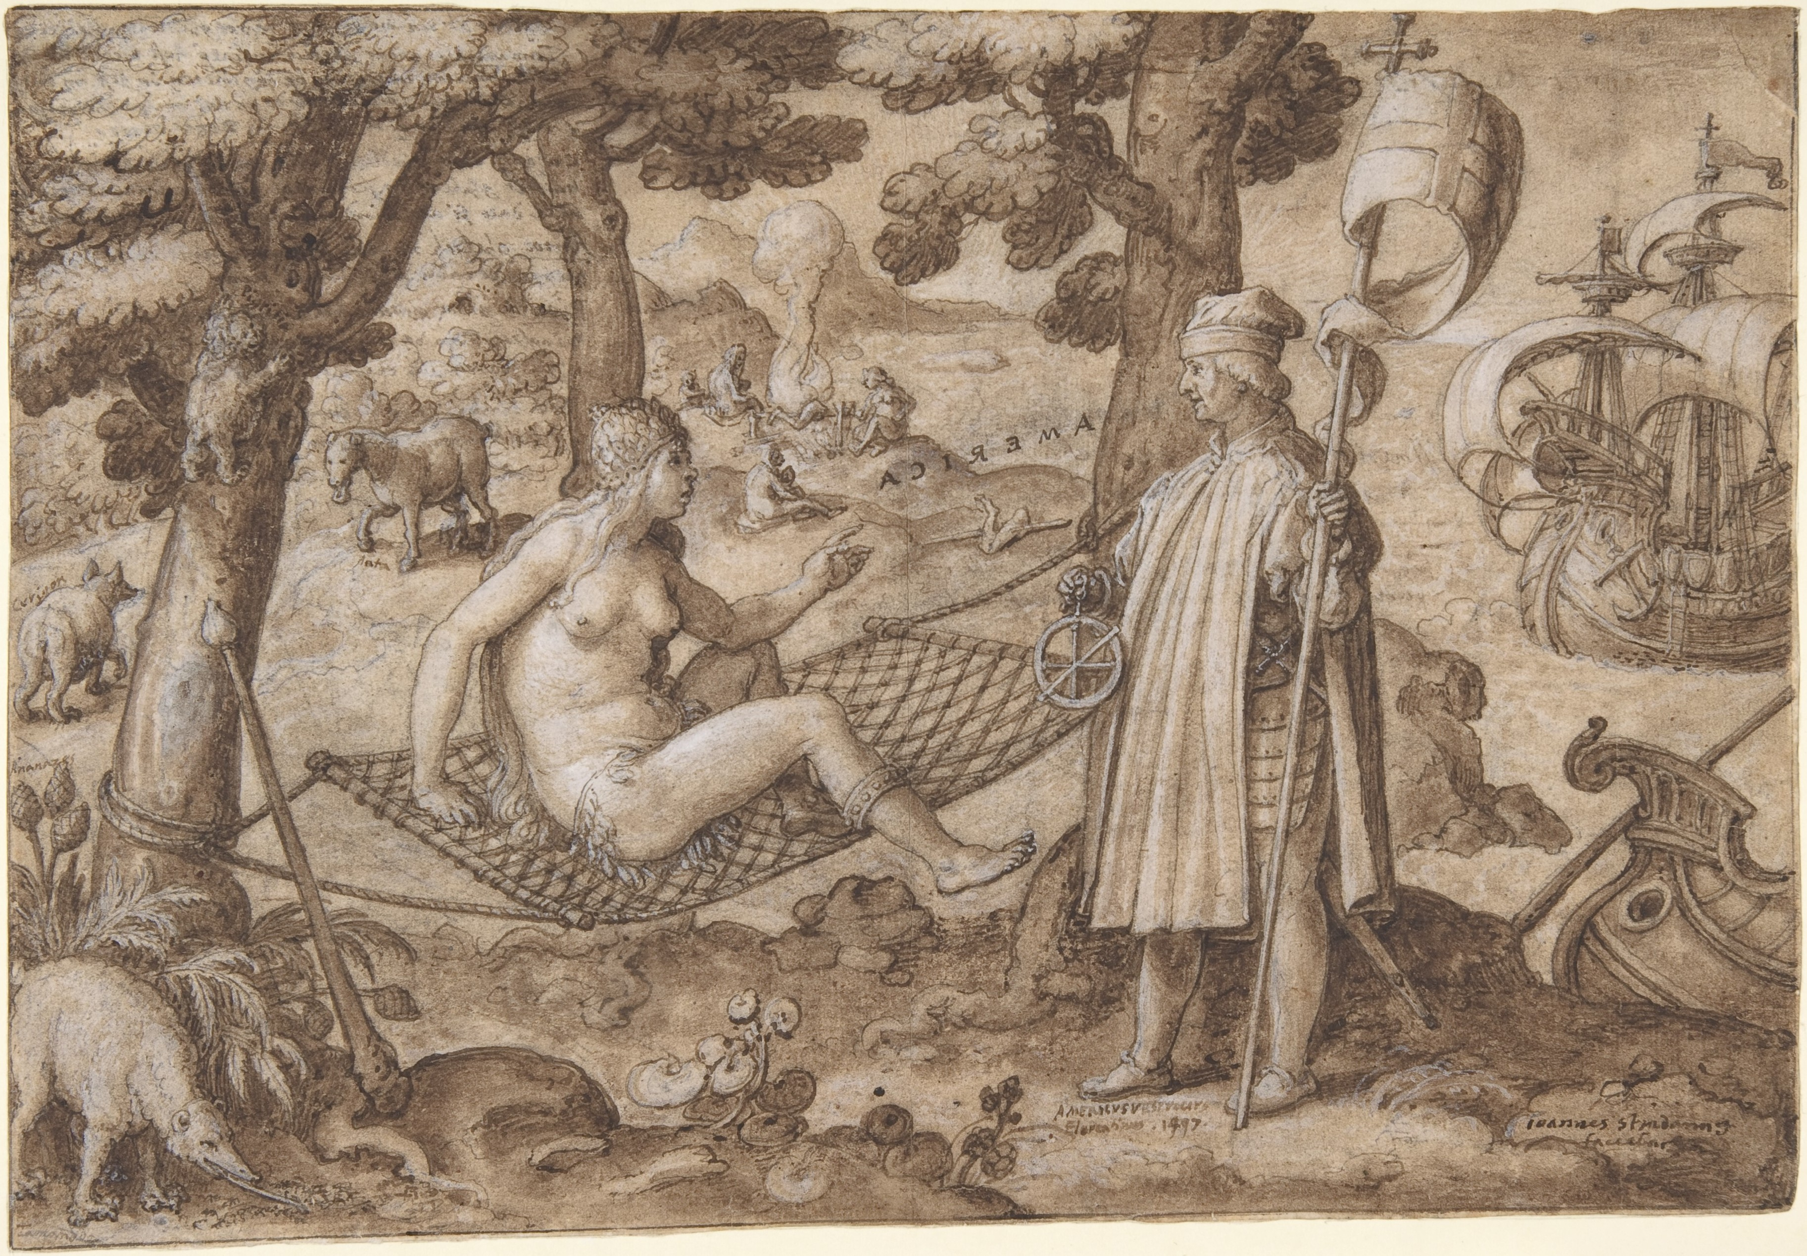

*Discovery of America* by Jan van der Straet (from the Metropolitan Museum of Art)

Amerigo Vespucci wakes a Native American woman and names her America

My hands were shaking from the cold, sloshing antifreeze on the asphalt as I tried to pour it into our radiator with a homemade funnel. My friend Jesse had offered to drive me from Chicago to my parents’ house in Ohio as I made my way back from a short but powerful trip to Standing Rock. The experience with the Indigenous-led DAPL resistance effort had left me feeling weightless, but after only a few hours on familiar highways I could feel myself being pulled back to the ground.

Driving through Ohio, steam had started to pour out of Jesse’s engine and the “overheated” warning icon lit up on his dashboard, despite the temperature outside having dropped into negative double digits. We pulled over at a gas station in downtown Cleveland, on a corner directly across from Progressive Field. I’d stood here in the summer sun a few months earlier when it was entirely barricaded with ten foot black riot fencing for the Republican National Convention. Now, after midnight in late November, the intersection was cold and dark, lit by a few streetlights and a glowing image of the Cleveland Indians mascot, Chief Wahoo.

Jesse looked up what he could on his smartphone and we both admitted how little we knew about engines. We tried to figure out a temporary fix and got back on I-77, only to pull over in the breakdown lane a few minutes later. The overheated engine was keeping us from traveling the remaining 40 minutes down the road to Wooster, where we’d spend the night. Wooster, Ohio: home of the Albright Radiator Shop, the family business where my grandfather, father, uncles, and several of my cousins have worked, many for their entire lives. As we sat in the car, trying to stay warm and watching strangers zip past, I wished I had ever bothered to learn about radiators.

After an hour or so, we got back on the road and crept home, the speedometer hovering around 35mph. It was after 3am when we finally pulled in the driveway. Upstairs, I sat on the edge of an empty queen-sized bed feeling especially isolated, and promised myself I wouldn’t forget the conviction I’d felt at Standing Rock. The experience, brief as it was, no more than 10 days, had spoken directly to something I needed in my life. Lakota leaders had done more than simply organize against the Dakota Access Pipeline, more than raise awareness of and denounce settler colonial culture; they had worked to create a community that served as a living example of the kinds of relationships and ways of inhabiting the earth that they insisted were possible. Native Leadership had cultivated an environment that allowed for unabashed optimism, was dedicated to communal spiritual practice, and nurtured a sense of purpose. I had determined to hang on to this sense, to resist sliding comfortably back into my own cynicism, the fear of being caught sincerely thinking a hopeful thought. I laid back and stared at the white ceiling, thinking about the stars. Feeling uneasy in the thick silence, I tried to sleep.

************

I woke up the next morning to pictures of people I’d met at Standing Rock in the national news. While we were trying to fix the car the night before, militarized police had faced off with Water Protectors at a bridge near the camp, spraying the group with water cannons in sub-zero temperatures, and seriously injuring some with flash grenades and rubber bullets. The pictures turned my stomach and the sudden spike in media attention was jarring. I watched friends and strangers on social media weigh in on the events – some supportive, some outright condescending to the people who had been injured. I read articles and watched broadcasts from a variety of national news outlets, some covering the use of force as a humanitarian issue, others as a justified response to unlawful protest. But what struck me the most about the media’s response was that there seemed to be no mention of the Water Protectors’ spiritual focus.

Anyone who had spent time at Standing Rock was quickly made aware that prayer and ceremony were unquestionably at the center of the movement. The message the Lakota leaders had offered was explicitly spiritual. The tool that was chosen to oppose the pipeline—not only in solace and reflection, but in direct action—was prayer. The omission of this aspect of the movement could only have been by choice. Maybe some assumed that the Water Protectors would be taken less seriously if associated with spirituality, and maybe others just didn’t want to complicate more straightforward calls for environmental and racial justice. Well-intentioned or not, this spiritual erasure left me feeling empty. And I wondered if it wasn’t somehow tied to the weight I’d felt ever since leaving camp.

Something was missing. I wanted to bring home experiences from my short time with the Lakota, which I knew offered wisdom for the situation I’d returned to, but the dangers of cultural appropriation were obvious. Lakota elders had advised that we get in touch with our own traditions, but I felt as clueless looking at my own tradition as I had staring at our broken radiator. I was left with a question that I think many non-Native people faced after moving experiences at Standing Rock: where do I go from here?

**************

A few months later, I came across Carolyn Merchant’s 1980 book *The Death of Nature: Women, Ecology and the Scientific Revolution*. In an early passage, Merchant, a professor of environmental history, philosophy, and ethics at the University of California, Berkeley, gives her take on the connection between European and Native American conceptions of nature:

“In the 1960’s, the Native-American became a symbol in the ecology movement’s search for alternatives to Western exploitative attitudes. The Indian animistic belief-system and reverence for the earth as a mother were contrasted with the Judeo-Christian heritage of dominion over nature and with capitalist practices … but European culture was more complex and varied than this judgment allows. It ignores the Renaissance philosophy of the nurturing earth as well as those philosophies and social movements resistant to mainstream economic change.”

Before the scientific revolution, suggests Merchant, European views of the natural world were, in many respects, aligned with those found in Native American nations. Merchant goes on to argue that the scientific revolution and the resulting mechanical worldview which took hold of the European imagination between 1500 and 1700, had caustic effects on society at large and it’s relation to the natural world.

Merchant hones in on the idea of a living earth, nearly universal before the period in question, which had served as a “constraining ethic,” putting restrictions on the exploitation of the environment. This ethic had been at work for millennia. The Roman historian Pliny (A.D. 23-79), for instance, wrote of mining practices in his time:

“We trace out all the veins of the earth, and yet… are astonished that it should occasionally cleave asunder or tremble: as though, forsooth, these signs could be any other than expressions of the indignation felt by our sacred parent! ... When will be the end of thus exhausting the earth, and to what point will avarice finally penetrate!”

Merchant offers examples of ethical restraints on mining operations up until the 1500’s, when arguments against this way of thinking began to develop. She points to Georg Agricola’s *De Re Metallica* (1556)*,* a compilation of arguments that aimed to allay fears of the ecological destruction wrought by mining operations that had polluted rivers and razed old-growth forests. In a telling instance of early-capitalist thinking, Agricola proposes that where mining had damaged local ecosystems, profits from the mines could be used to purchase “edible beasts and fish” and “birds without number” to restock the forests and streams, thus restoring the natural order. Agricola’s work was influential in lifting traditional constraints and sanctioning mining as a commercial practice.

But a more drastic turn in thinking, according to Merchant, came about when enlightenment era philosophers sought to entirely transform how we perceive the world around us. Mathematician Johannes Kepler perhaps best summed up this new emerging ethos when he wrote to a friend in 1605, “my aim is to show that the celestial machine is to be likened not to a divine organism but to a clockwork.” This new metaphor—of a mechanical, insensate universe—would eventually overshadow all other European conceptions of the earth or the cosmos as a living being. As this ideology took hold, Merchant argues, Europe began “a slow but unidirectional alienation from immediate daily organic relationship that had formed the basis of human experience from earliest times.” Europeans in this time period witnessed a shift in thinking that split mind from body, spirit from matter, that emphasized atomization and compartmentalization, that conceived of the natural world as a resource, enclosing communal lands and working hand in hand with a rising capitalist order to radically alter the European landscape. The ways this transformation has shaped even our most basic interactions with the surrounding world are hard to fully appreciate.

****************

Challenging the nearly unquestioned reverence for the men who stood at the forefront of the scientific revolution, Merchant provides numerous examples of how their new mechanical worldview immediately led to violent, even sociopathic personal behaviors. Rene Descartes, for example, perhaps the most influential Western Philosopher of this era, was known to perform gruesome, live dissections of animals, believing that their yelps and cries were no more than unfeeling mechanical reactions. Merchant offers similar stories of many other revered enlightenment thinkers, but she focuses her critique on broader social effects.

The book lays out a compelling argument that the mechanistic worldview, as it further withdrew from the natural world, played an important role in the subjugation of women and people of color. One particularly damning example Merchant presents, often overlooked by historians, is the support offered by many enlightenment era thinkers of the European Witch Hunts, in which hundreds of thousands of women were rounded up, tortured, interrogated, and executed. Francis Bacon, often considered the father of modern science, in addition to ardently supporting the Witch Hunts, drew comparisons between the inquisition of witches and the “inquisition of nature,” in developing his scientific method:

“You have but to follow and as it were hound nature in her wanderings, and you will be able when you like to lead and drive her afterward to the same place again… a useful light may be gained [in the study of witchcraft], not only for a true judgment of the offenses of persons charged with such practices, but likewise for the further disclosing of the secrets of nature. Neither ought a man to make scruple of entering and penetrating into these holes and corners, when the inquisition of truth is his whole object.”

Merchant summarizes Bacon’s thoughts, using his own language:

The new man of science must not think that the “inquisition of nature is in any part interdicted or forbidden.” Nature must be “bound into service” and made a “slave,” put “in constraint” and “molded” by the mechanical arts.

Merchant notes that the women targeted in these Witch Hunts were in many ways, victims of a nascent European colonialism, and that remarkably similar terrors awaited many Native Americans in the “new world,” sometimes at the hands of the same European men. In both cases, Merchant reminds us, these tactics were a means of social control meant to suppress struggles led by women and people of color against the enclosure and privatization of communal lands.

Merchant proposes that the terrorizing of people of color, dehumanization of women, and estrangement from our environment are all directly connected to the concepts of Nature and Culture. In addition to splitting spirit from matter, Merchant argues, the scientific revolution inflated the poisonous European idea that human beings, and more specifically white males, were somehow outside of nature. She writes:

“As the unifying bonds of the older hierarchical cosmos were severed, European culture increasingly set itself above and apart from all that was symbolized by nature… If nature and women, Indians and Blacks (*sic*) are to be liberated from the strictures of this ideology, a radical critique of the very categories *nature* and *culture*, as organizing concepts in all disciplines, must be undertaken.”

The challenge we face, suggests Merchant, is dismantling a sort of cosmic arrogance of masculine, Eurocentric thinking that sees women, people of color, and the earth as resources to be exploited. I remembered Lakota leaders at Standing Rock emphasizing that gender equality and racial justice are profoundly tied to environmental justice. At the center of every speech had been a call for spiritual and cultural transformation, a complete upheaval of society and a rethinking of the way we interact with the world. As Lakota scholar and activist Nick Estes had put it: “not just a political revolution but a radical restructuring of our social relations—how we relate to each other indelibly affects how we relate to the nonhuman world.”

**********

In the months after Standing Rock, I kept returning to powerful memories of awe I had experienced at camp, and especially to the moment that had overpowered me on the day by the railroad tracks. The pervasive sense of spirituality I’d experienced among the Lakota was not abstract in the sense of being otherworldly; it was a reverence for everything that is profoundly of this world. This is what I’d felt slipping away as I worked my way back home. It was the difference between standing around a fire on an open prairie and sitting stranded in a car on the side of the highway. Water Protectors had referred to it simply as a respect for what is sacred.

As I thought about this concept of the sacred, strongly connected to the idea of a living earth and completely at odds with the mechanical worldview examined by Merchant, I thought about how powerful a sense of the sacred could be in changing our understanding of the world. I remembered something I’d read years ago that addressed this tension from a scientific perspective. It was an open letter on the Climate Crisis written in 1990 by the scientist Carl Sagan:

“We are now threatened by self-inflicted, swiftly moving environmental alterations about whose long-term biological and ecological consequences we are still painfully ignorant … a global warming unprecedented in the last 150 millennia; the obliteration of an acre of forest every second; the rapid-fire extinction of species; and the prospect of a global nuclear war which would put at risk most of the population of the Earth… Problems of such magnitude, and solutions demanding so broad a perspective must be recognized from the outset as having a religious as well as a scientific dimension.”

This “Appeal for Joint Commitment in Science and Religion,” signed by 34 of the worlds leading contemporary scientists, invoked the sense of wonder inspired by studying the cosmos:

“As scientists, many of us have had profound experiences of awe and reverence before the universe. We understand that what is regarded as sacred is more likely to be treated with care and respect. Our planetary home should be so regarded. Efforts to safeguard and cherish the environment need to be infused with a vision of the sacred.”

Sagan’s letter was published the same month I was born. 27 years later, I’m wondering what the world would be like if its message had been taken to heart. Instead, today even the most conservative estimates put us past a critical turning point for addressing climate change. The predictions of what’s to come range from disastrous to apocalyptic. The decline in wildlife we are already witnessing is a tragedy difficult to fathom. **[Link http://www.pnas.org/content/114/30/E6089]**  Meanwhile, the current president of the United States denies the existence climate change and earlier this year announced that he’d signed an executive order to approve the Dakota Access Pipeline “with [his] eyes closed.”

It’s almost paralyzing to think of where we’re at in coming to terms with the crisis we face. I remember counter-protesters in North Dakota who followed Water Protectors shouting “Oil is life!” and wonder to what extent they were being sincere. How do you persuade someone who feeds their family by working in an oil field to leave it behind? How, even if you are convinced of the need for drastic change, do you enact it? The kind of radical transformation we so urgently need would require everyone, regardless of political leanings. But how can we expect a concerted global effort when so many people are dealing with the their own personal crises? **[Link to Letter from Editors]**

A year after Sagan wrote his letter, hundreds of religious leaders from around the world, including Chiefs of several Indigenous nations, offered their response:

“We reaffirm here, in the strongest possible terms, the indivisibility of social justice and ecological integrity. An equitable international economic order is essential for preserving the global environment. Economic equity, racial justice, gender equality, and environmental well-being are interconnected and all are essential to peace… It has taken the religious community, as others, much time and reflection to start to comprehend the full scale and nature of this crisis and even to glimpse what it will require of us. We must pray ceaselessly for wisdom, courage, and creativity. Most importantly, we are people of faith and hope. These qualities are what we may most uniquely have to offer to this effort. We pledge to the children of the world and, in the words of the Iroquois, ‘to the seventh generation,’ that we will take full measure of what this moment in history requires of us. In this challenge may lie the opportunity for people of faith to affirm and enact, at a scale such as never before, what it truly means to be religious.”

**********

As I write from my room on the Lower East Side of Manhattan, I can hear the news on a TV nearby reporting on a recent series of record breaking natural disasters taking place around the world including a series of Hurricanes which have devastated the Carribean and parts of the US Southeast. As the climate reacts violently to the extraction and burning of fossil fuels, the idea of the earth as a living creature presents itself more stubbornly. And as images circulate of people wading through chest-high water looking for something to drink, the phrase “Water Is Life” takes on new dimensions.

I think about the religion of the Lakota, shaped by over 200 years of persecution, which I saw meeting tools of violence at Standing Rock with prayer and compassion, meeting threats of environmental and cultural degradation with a deep sense of hope. The Lakota have known what it means to fight for existence.

I glance out my window at a small square of sky, listening to the clang of construction, the steady hum of traffic, and wonder how much longer we can plod along as usual. The built world so powerfully reinforces the beliefs that designed it; it promises stability, mastery, and invulnerability. But a change is coming, unlike anything we’ve seen before. In the coming years, I wonder: what will it mean to be religious?

*Nathan Albright is a Cofounding Editor at The Flood.*